Extending LVM Volume on RHEL with NVMe Disk
Command: #lsblk
Observation:
The system root and boot are on nvme0n1.
Application data is managed via vg_data.
nvme0n3 was free and available for allocation.
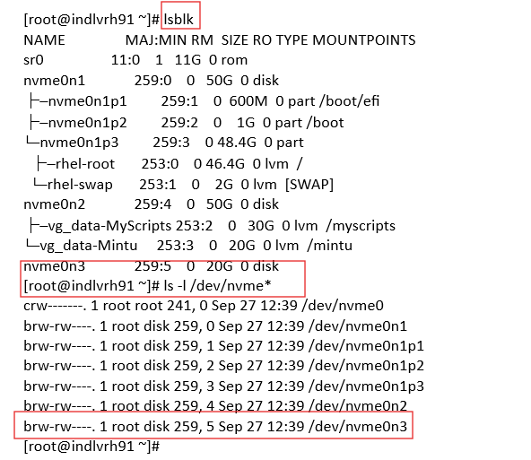

Step 1 – Partition the new disk

Command: #fdisk /dev/nvme0n3
- Created a 5G partition (nvme0n3p1)
- Changed type → Linux LVM (8e)
- Saved changes
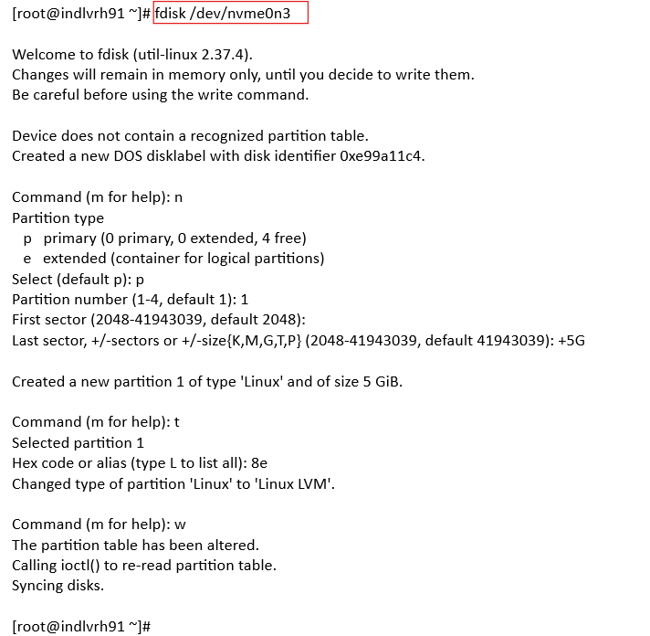
Command: #lsblk
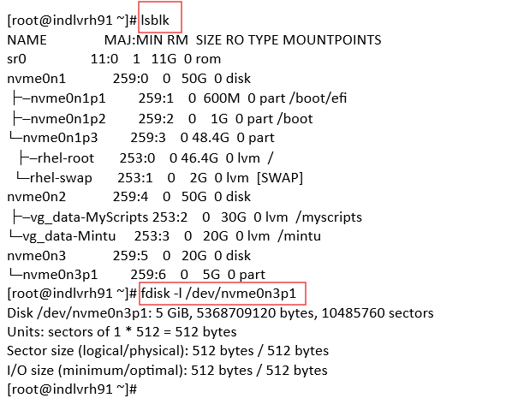
Observation: Partition nvme0n3p1 successfully created.

Step 2 – Create Physical Volume (PV)
Command : #pvcreate /dev/nvme0n3p1; #pvs
Output:
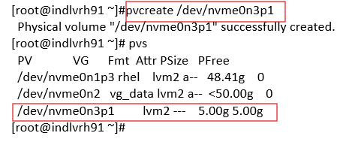
/dev/nvme0n3p1 lvm2 --- 5.00g 5.00g free
Observation: nvme0n3p1 is now available as a new PV.

Step 3 – Extend Volume Group (VG)
Command : #vgextend vg_data /dev/nvme0n3p1; #vgs
Output:
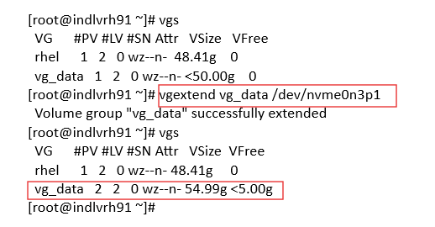
Volume group "vg_data" successfully extended
Observation: VG vg_data grew from 50G → ~55G, with 5G free space.

Step 4 – Extend Logical Volume (LV)
First attempt (failed):
#lvextend -L +5G /dev/mapper/vg_data-Mintu
Error: Insufficient free space: 1280 extents needed, but only 1279 available
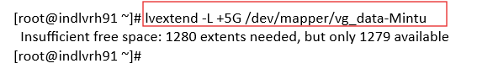
Final command (success): (Without -r)
# lvextend -l +100%FREE /dev/mapper/vg_data-Mintu
# resize2fs /dev/mapper/vg_data-Mintu
#lvs
Size of logical volume vg_data/Mintu changed from 20.00 GiB to 24.99 GiB
Logical volume vg_data/Mintu successfully resized
Check:
#lvs
Output:
Mintu vg_data -wi-ao---- 24.99g
Observation: LV Mintu extended from 20G → ~25G.

Step 5 – Resize Filesystem
With -r option:
#lvextend -l +100%FREE /dev/mapper/vg_data-Mintu -r
Output:
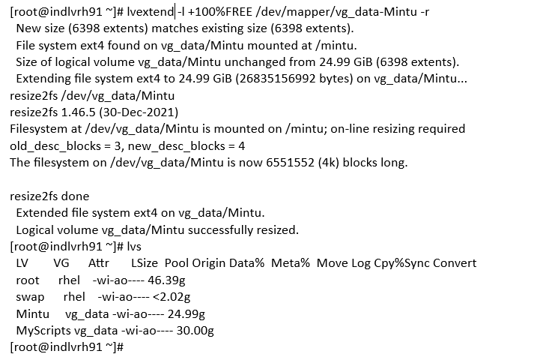

Observation: Filesystem expanded online without downtime.

Step 6 – Verify FS
# df -hT
Output:
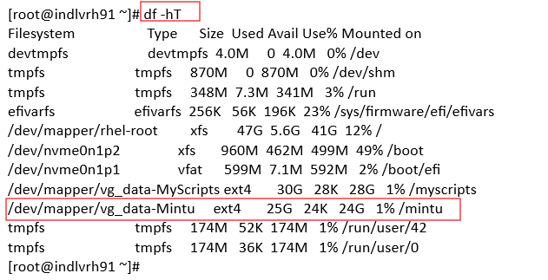
/dev/mapper/vg_data-Mintu ext4 25G 24K 24G 1% /mintu

Observation: Filesystem /mintu is now 25G.

Final Notes
Added nvme0n3p1 as new PV → Extended vg_data → Extended LV Mintu.
Logical Volume grew from 20G → 24.99G.
Filesystem resized online (no reboot required).
✅ Disk space increased successfully.

Creating a Snapshot after Extending the VG

Step 1: Attempt to Create a Snapshot (Fails)
Commands:
#lvcreate -L 2G -s -n Mintu_snapshot /dev/vg_data/Mintu
#lvcreate -L 1G -s -n Mintu_snapshot /dev/vg_data/Mintu

What it does:
Tries to create a snapshot of LV Mintu.
-L specifies snapshot size; -s indicates snapshot LV.
Error:
Volume group "vg_data" has insufficient free space
Reason: VG vg_data had no free extents to allocate for the snapshot.
*Note: if there is disk space, then no need of extension*
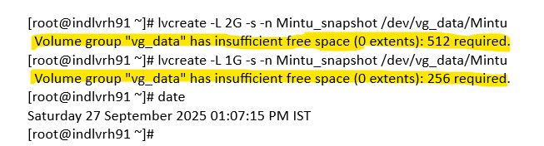

Step 2: Create a New Partition on a Disk
Command: #fdisk /dev/nvme0n3
Steps inside fdisk:
n → create a new partition
Choose primary (p) → partition number 2
Specify size +5G → creates a 5 GiB partition
w → write changes to disk
Result:
Disk /dev/nvme0n3 now has a new partition /dev/nvme0n3p2.
Why:
Need additional space for VG vg_data to accommodate snapshots.
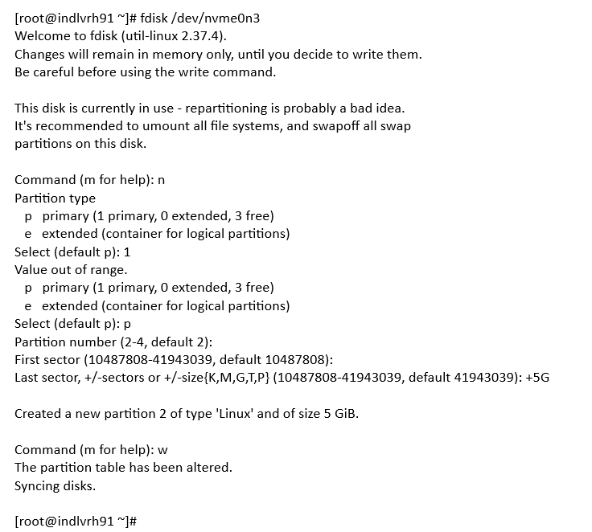

Step 3: Verify Partitions
Command: #lsblk
Observation:
Shows all disks and partitions.
/dev/nvme0n3p2 exists (5G) → ready to use as PV.
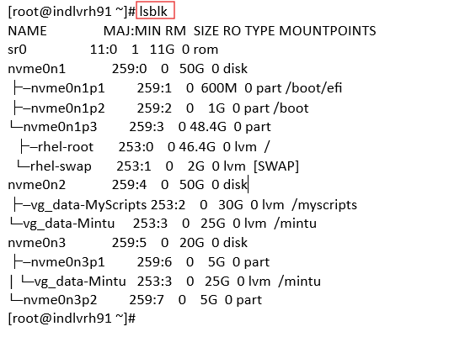

Step 4: Create Physical Volume
Command: #pvcreate /dev/nvme0n3p2
Purpose:
Initializes the new partition as a physical volume (PV) for LVM.
Result:
PV successfully created.
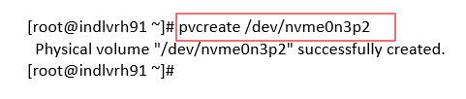

Step 5: Extend Volume Group
Command: #vgextend vg_data /dev/nvme0n3p2
Purpose:
Adds the new PV to volume group vg_data.
This increases free space in VG, enabling snapshot creation.
Result:
VG successfully extended → now enough free space for snapshot.
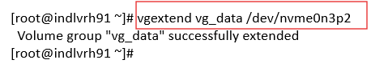
Step 6: Create the Snapshot
Command: #lvcreate -L 1G -s -n Mintu_snapshot /dev/vg_data/Mintu
Purpose:
Creates a 1 GiB snapshot of LV Mintu.
Snapshot LV stores changes to the original LV after creation.
Result:
Snapshot LV Mintu_snapshot successfully created.
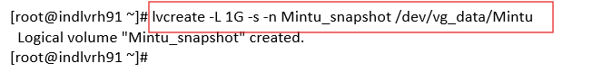

Step 7: Verify Logical Volumes
Commands:
# lvs -a
# lvdisplay /dev/vg_data/Mintu
# lvdisplay /dev/vg_data/Mintu_snapshot
Observations:
lvs -a shows:
- Mintu → original LV, source of snapshot
- Mintu_snapshot → active snapshot, 1G COW table
lvdisplay /dev/vg_data/Mintu:
- Confirms Mintu_snapshot is active snapshot
- LV size: 24.99 GiB
lvdisplay /dev/vg_data/Mintu_snapshot:
- LV size: 24.99 GiB (snapshot mirrors original LV)
- COW-table size: 1G
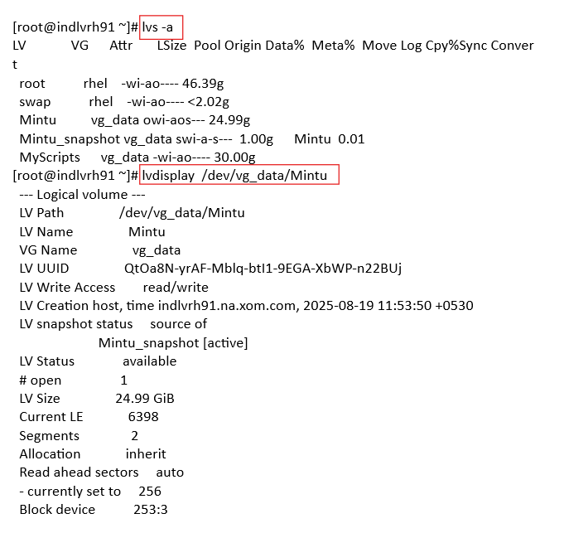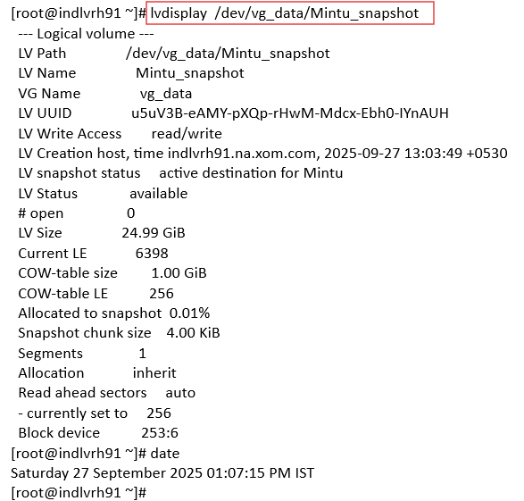

“Step 8 involves deleting the LVM snapshot as part of the disk resize procedure. Post-deletion, verification of successful removal and monitoring for any system inconsistencies is recommended.”
Verification:
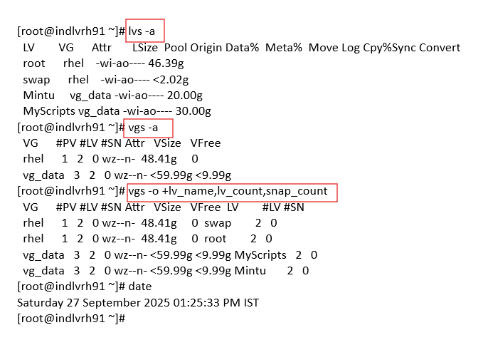

Shrinking an LVM Logical Volume (Mintu)

Step 1: Check Logical Volume Details
Command: #lvdisplay /dev/vg_data/Mintu
What it does:
Displays detailed information about the LV Mintu, including size, VG, snapshot status, segments, and block device.
Observation:
- LV Mintu size: 24.99 GiB
- LV snapshot status: source of Mintu_snapshot [active] → this means there’s an active snapshot of this LV, which prevents shrinking.
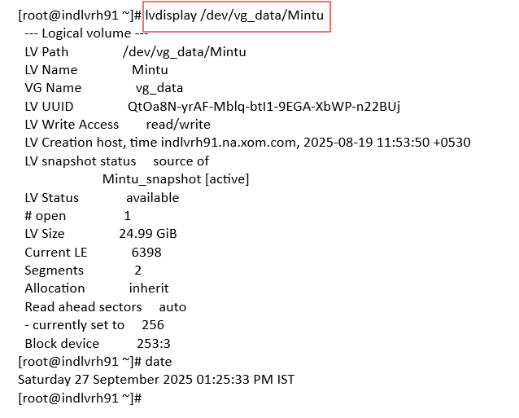

Step 2: Check Filesystem Details
Command: #df -T /mintu
What it does:
Shows filesystem type and usage.
Observation:
- Filesystem type: ext4
- LV is mounted at /mintu
- Size on disk: 25G
- Only 24K used, 19G available → plenty of free space.
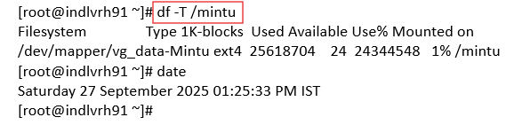

Step 3: Unmount the filesystem (required for shrinking ext4 safely)
Command: #umount /mintu; # lsof /mintu
Why:
Shrinking a filesystem requires it to be unmounted to prevent data corruption (especially ext4).
Purpose:
- Checks for open files on /mintu.
- Output is empty → safe to proceed.
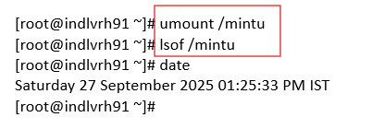

Step 5: Check Filesystem for Errors
Command: #e2fsck -f /dev/vg_data/Mintu
Why:
Before resizing, filesystem integrity must be verified.
-f forces a check even if the filesystem seems clean.
Observation:
Filesystem clean → no errors, ready to resize.
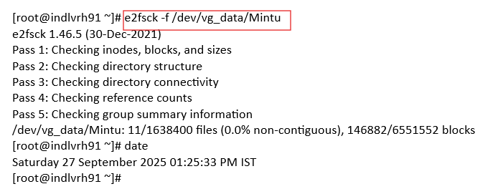

Step 6: Shrink Filesystem
Command: #resize2fs /dev/vg_data/Mintu 20G
What it does:
Shrinks the ext4 filesystem from 24.99G to 20G.
Important: filesystem must be shrunk first before reducing the LV size.

Result:
Filesystem now occupies 20G on disk.
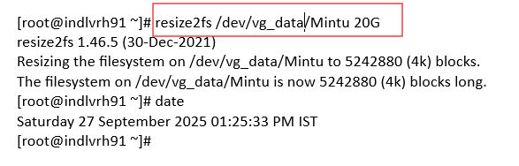

Step 7: Attempt to Reduce LV Size (Fails Initially)
Command: #lvreduce -L 20G /dev/vg_data/Mintu
Observation:
- Error: Snapshot origin volumes cannot be reduced in size yet
- Reason: LV Mintu has an active snapshot (Mintu_snapshot), which prevents shrinking the LV.
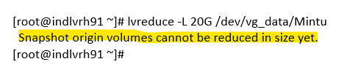

Step 8: Remove the Snapshot
Command: # lvremove /dev/vg_data/Mintu_snapshot
Why:
To shrink a logical volume, any snapshots of that LV must be removed.
Confirmation y → snapshot successfully removed.
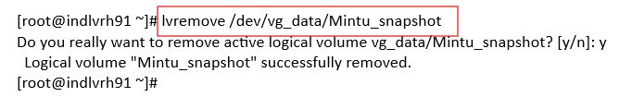

Step 9: Reduce the LV Size
Command: #lvreduce -L 20G /dev/vg_data/Mintu
What it does:
Shrinks the LV Mintu from 24.99G → 20G.
Since filesystem is already 20G, lvreduce reports:
File system size is equal to requested size → no further filesystem shrinking needed.
Result:
LV successfully reduced to 20 GiB.
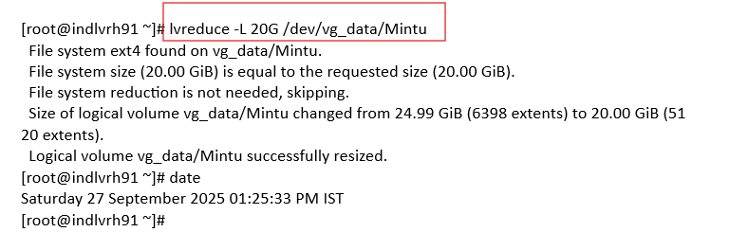

Step 10: Remount and Verify the Shrunk LV
Command: #mount /mintu; # df -h /mintu
Why:
Makes LV available again for normal use.
Observation:
- Size: 20G
- Used: 24K
- Available: 19G
- LV now properly shrunk and filesystem intact.
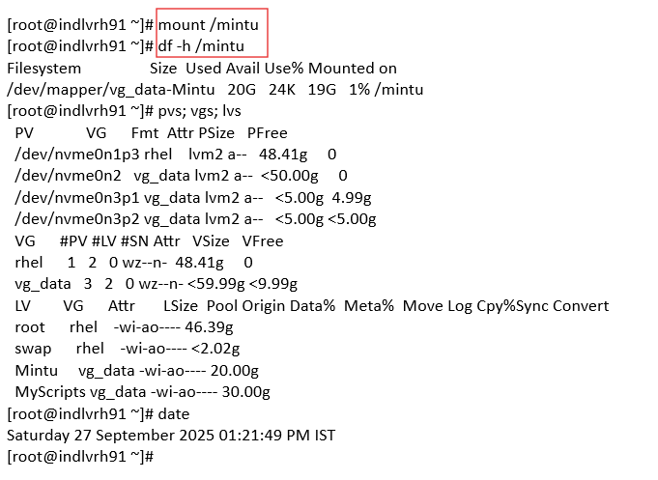
Key points:
- Always shrink the filesystem before the LV.
- Snapshots prevent shrinking; they must be removed first.
- Unmounting and filesystem checks prevent data corruption.

Disk Health Check Report and Checklist
1. Filesystem Integrity
Command:
#fsck -n /dev/vg_data/Mintu
Output:
/dev/mapper/vg_data-Mintu: clean, 11/1638400 files, 146882/6551552 blocks
Interpretation:
-n = read-only, no modifications.
Filesystem is clean (no corruption detected).
✅ Filesystem layer is healthy.
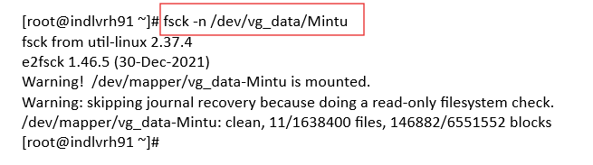

2. SMART Health (NVMe Disks)
Command:
# smartctl -a /dev/nvme0n1
#smartctl -a /dev/nvme0n2
#smartctl -a /dev/nvme0n3
Key Findings:
- SMART overall-health: PASSED
- Errors: 0
- Temperature: Reported as 11759°C (invalid — VMware virtual disk bug)
- Available Spare: 1% (ignore in virtualization)
- Percentage Used: 0%
- Interpretation:
All disks passed SMART checks.
Unrealistic counters due to VMware virtualization.
No media or integrity errors reported.
✅ SMART layer is healthy.
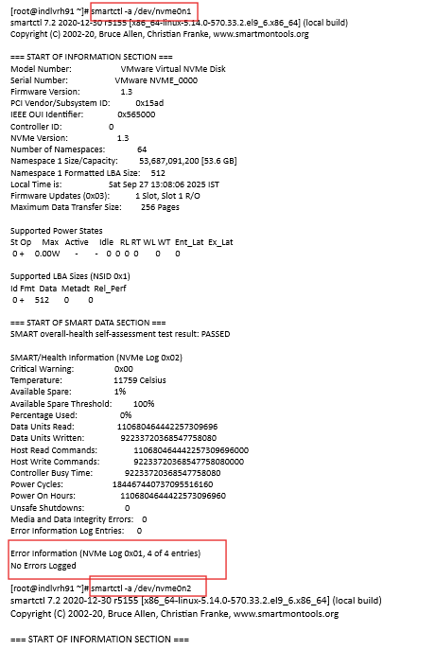

3. Bad Block Scan
Command:
#badblocks -v /dev/nvme0n3
Output:
Pass completed, 0 bad blocks found.
Interpretation:
No bad sectors detected on /dev/nvme0n3.
✅ Physical block integrity confirmed.
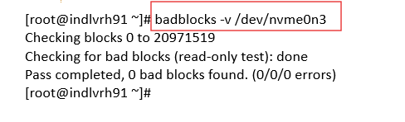

4. LVM Metadata
Commands:
#vgck vg_data
# lvdisplay /dev/vg_data/Mintu
#pvs
Output:
- No errors in volume group metadata.
- All PVs are detected and consistent.

✅ LVM layer is intact.
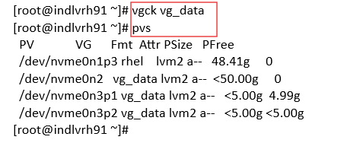
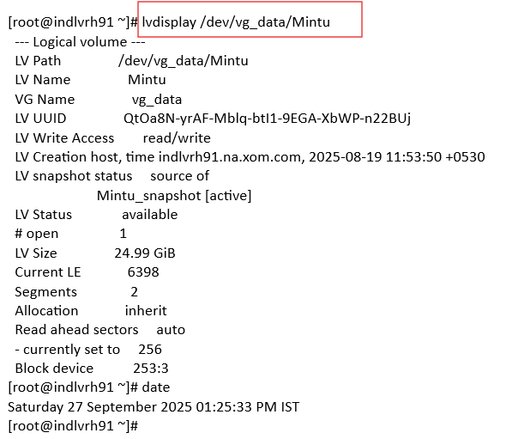

Overall Status
Disk | SMART Health | Bad Blocks | Filesystem | LVM Metadata | Status
/dev/nvme0n1 | PASSED | Not tested | N/A | OK (rhel VG) | Healthy
/dev/nvme0n2 | PASSED | Not tested | N/A | OK (vg_data) | Healthy
/dev/nvme0n3 | PASSED | 0 errors | N/A | OK (vg_data) | Healthy
/dev/vg_data/Mintu | N/A | N/A | Clean | N/A | Healthy

✅ All disks and the filesystem appear healthy.

Conclusion
The disks /dev/nvme0n1, /dev/nvme0n2, and /dev/nvme0n3 are all healthy.
The filesystem on /dev/vg_data/Mintu is clean.
No corrective actions are required at this time.

